AZURE CLI

Task: Create a virtual machine using the azure portal, Install a web server and host a simple webpage

Task: Manage the created virtual machine ,demonstrating how to start, stop and resize the VM.

1. Login to azure cli

1. Create a resource group

1. Create a VM in newly created resource group

1. Access the command line of VM that is created

5.Update the software so that the latest package is installed in future

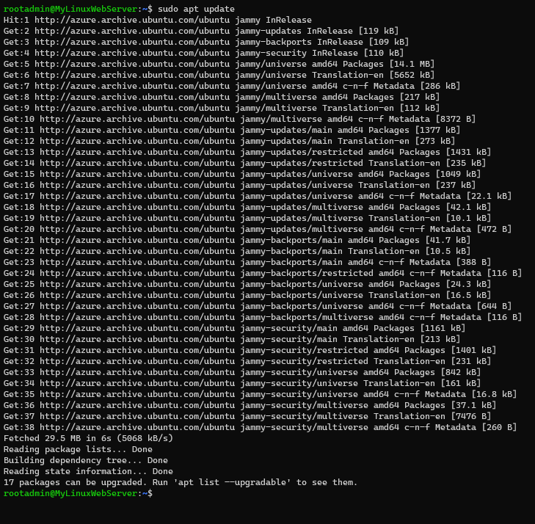

6.Install nginx

7.verify if the default html page is working

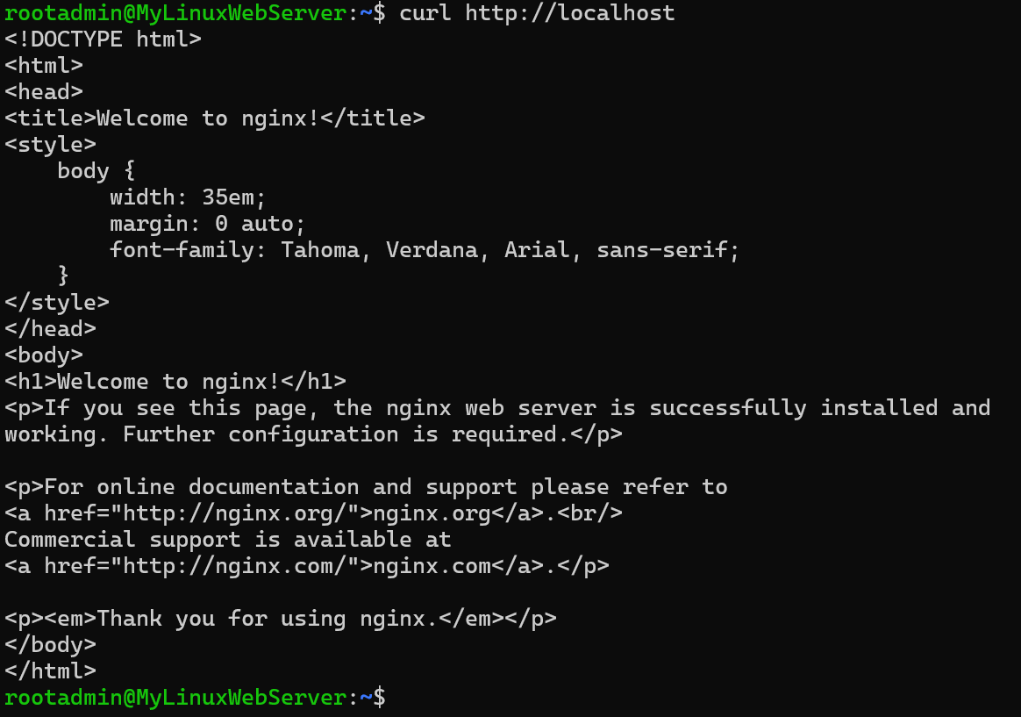

8.Add an inbound security rule to the My Linux Server NSG having port 80 and priority of 300

9. Give access to Read, Write and Execute to the files to HTML and CSS files in the VM.

10.Create a HTML, CSS project on your local machine that needs to be hosted on the newly created VM.



